File 52_region_road_cost.csv
May 12, 2026
Definition of the Input File
VisionEval (https://visioneval.github.io/docs/model-inputs.html) explains that this file contains different types of road costs. This file contains six attributes:
- RoadBaseModCost: Average base modernization cost per light-duty vehicle mile traveled (dollars per vehicle mile). Base modernization includes roadway improvements exclusive of addition of lanes.
- RoadPresOpMaintCost: Average road preservation, operations, and maintenance cost per light-duty vehicle mile traveled (dollars per vehicle mile).
- RoadOtherCost: Average other road cost (e.g. administration, planning, project development, safety) per light-duty vehicle mile traveled (dollars per vehicle mile).
- FwyLnMiCost: Average cost to build one freeway lane-mile (dollars per lane-mile)
- ArtLnMiCost: Average cost to build one arterial lane-mile (dollars per lane-mile)
- HvyTrkPCE: Passenger car equivalent (PCE) for heavy trucks. PCE indicates the number of light-duty vehicles a heavy truck is equivalent to in calculating road capacity.
For example, the data below suggest that the average base modernization cost per light-duty vehicle mile traveled in 2024 is 0.0258451 dollars per vehicle mile in 2022 dollars. In addition, the average cost to build one freeway lane-mile in 2024 is 10,344 dollars per lane-mile in 2018 dollars. The same values were applied in 2045 because it was assumed that there would be no increase beyond inflation.
Possible Scenario
The document Task 7.2 Simplified Scenario Development guide, available at A Playbook for Simplified Approaches for Creating Scenarios in VisionEval, does not explicitly reference this file. However, if roadway costs are expected to increase beyond inflation due to factors such as labor, material, or regulatory costs, the values in this file could be adjusted accordingly. Such changes would likely affect congestion- and delay-related outputs.

Method Used for Virginia
Base Year
To obtain RoadBaseModCost, RoadPresOpMaintCost, and RoadOtherCost, the 28th Annual Highway Report published by the Reason Foundation on March 13, 2025, was used. Although the latest report was released in 2025, the dataset reflects 2022 values. Since deflators are applied within the model, the 2022 data were used without modification.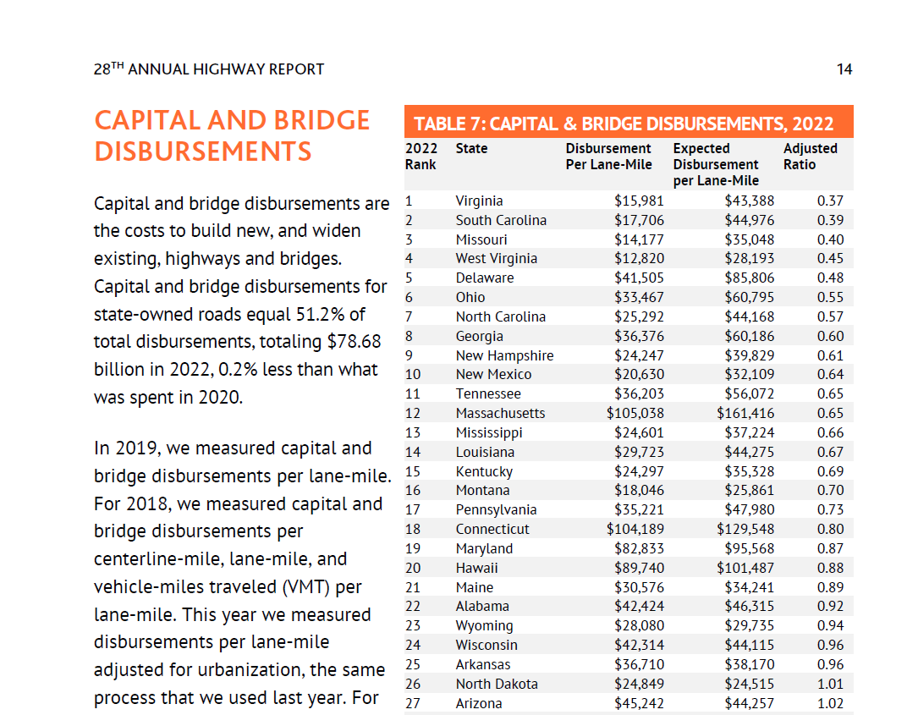

Each input variable in the CSV file was mapped to the corresponding data from the 28th Annual Highway Report published by the Reason Foundation.
Input Variable ($/VMT) | 28th Annual Highway Report
RoadBaseModCost.2005 | $15,981 (Disbursement Per Lane-Mile, Table 7: Capital & Bridge Disbursement, 2022)
RoadPresOpMaintCost.2005 | $18,505 (Disbursement Per Lane-Mile, Table 8: Maintenance Disbursements, 2022)
RoadOtherCost.2005 | $3,787 (Disbursement Per Lane-Mile, Table 9: Administrative Disbursements, 2022)  $7,160 (Disbursement Per Lane-Mile, Table 10: Other Disbursements, 2022)

To convert the values from dollars per lane-mile to dollars, Virginia’s total lane-miles (129,519), reported in “Table 6: State-Controlled Highway Mileage by System Width, 2022,” were used. Based on this figure, the previously calculated values were converted to dollars as shown below.
Dollars per Lane-miles | Dollars
$15,981 | $2,069,843,139
$18,505 | $2,396,749,095
$10,947 | $1,417,844,493

To estimate VMT, this analysis referenced the dataset titled “2022 Report 1226: VMT by Physical Jurisdiction by Federal Vehicle Class, Towns Rolled into Counties,” which was also used in preparing marea_dvmt_split_by_road_class.csv. According to the module documentation for BalanceRoadCostsAndRevenues, each cost input variable is defined as the cost per light-duty vehicle mile traveled (dollars per vehicle mile). Therefore, only the DVMT associated with Passenger Cars and Two-Axle, Four-Tire Single-Unit Vehicles was included in the calculation. The combined daily DVMT for these two vehicle classes is 219,414,784. On an annual basis, this equates to 80,086,396,224 vehicle miles traveled per year. The intermediate calculation result is shown below:
Input Variable | Dollars | Dollars per VMT
RoadBaseModCost | $2,069,843,139 | $0.0258451
RoadPresOpMaintCost | $2,396,749,095 | $0.0299270
RoadOtherCost | $1,417,844,493 | $0.0177039

To obtain FwyLnMiCost.2005.1e3 and ArtLnMiCost.2005.1e3, the FHWA report titled Status of the Nation’s Highways, Bridges, and Transit: Conditions and Performance (25th edition, published in 2024) was used. Although the report was published in 2024, the data reflect 2018 values.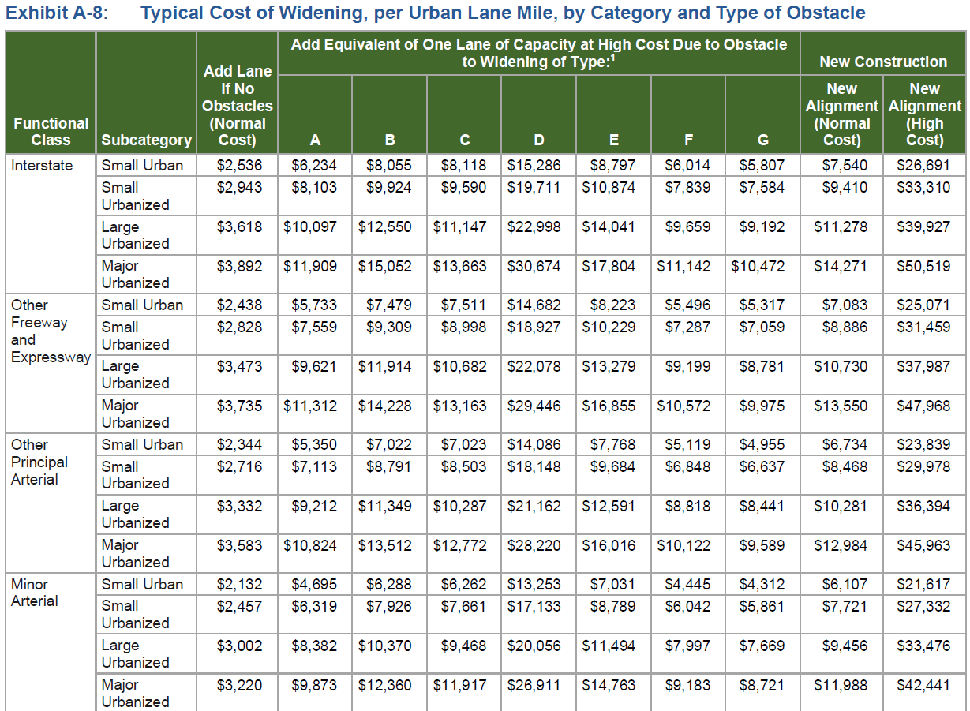
The “New Alignment (Normal Cost)” values from Exhibit A-8 were used, considering the macro-level nature of the VisionEval model. However, the accuracy of the analysis could be improved by applying location-specific cost values that better reflect the characteristics of the study area.
Roda type | Terrain Type | New Construction
 |  | New Alignment (Normal Cost)
Interstate | Small Urban | $ 7,540.00
 | Small Urbanized | $ 9,410.00
 | Large Urbanized | $ 11,278.00
 | Major Urbanized | $ 14,271.00
Other Freeway and Expressway | Small Urban | $ 7,083.00
 | Small Urbanized | $ 8,886.00
 | Large Urbanized | $ 10,730.00
 | Major Urbanized | $ 13,550.00
Other Principal Arterial | Small Urban | $ 6,734.00
 | Small Urbanized | $ 8,468.00
 | Large Urbanized | $ 10,281.00
 | Major Urbanized | $ 12,984.00
Minor Arterial | Small l Urban | $ 6,107.00
 | Small Urbanized | $ 7,721.00
 | Large Urbanized | $ 9,456.00
 | Major Urbanized | $ 11,988.00

For mapping purposes, arithmetic average values were used.
VisionEval Input Variables |  | Corresponding Road Types | Cost per Lane-Mile (2018 USD)
Freeway Lane-Mile Cost |  | Interstate, Other Freeway, and Expressway | $10,344 (arithmetic average)
Arterial Lane-Mile Cost |  | Other Principal Arterial and Minor Arterial | $9,217 (arithmetic average)
The final result is shown below. The field name was updated to reflect the input value year, and was revised to 2018 accordingly.
Year | FwyLnMiCost.2018.1e3 | ArtLnMiCost.2018.1e3
2024 | 10.344 | 9.217
2045 | 10.344 | 9.217

To obtain HvyTrkPCE, the Highway Capacity Manual 2010, published in December 2010, was used. Although more recent editions of the Highway Capacity Manual (HCM 6th Edition, 2016; HCM 7th Edition, 2022) are available, this analysis references HCM 2010 because it provides clearly defined passenger car equivalent (PCE) values by facility type and terrain condition. Based on Exhibit 11-10 of HCM 2010, which presents truck PCE values by terrain type, a value of 2.0 was selected. This value represents the simple average of the values for level terrain (1.5) and rolling terrain (2.5), reflecting the general topographic characteristics of the Virginia highway network. However, these values may need to be adjusted depending on the specific characteristics of the study area. 

Forecast Year
Regarding RoadBaseModCost, RoadPresOpMaintCost, and RoadOtherCost, the 2024 values expressed in 2022 dollars were also applied to the 2045 forecast year due to the lack of available forecasting data sources. However, as noted earlier in the Definition of the Input File section, the values still reflect inflation effects within the model, even though the numeric values remain the same, because they are expressed in constant 2022 dollars.
Regarding FwyLnMiCost.2005.1e3 and ArtLnMiCost.2005.1e3, the 2024 values expressed in 2018 dollars were likewise applied to the 2045 forecast year for the same reason described above.
The forecast-year value for HvyTrkPCE was assumed to remain the same as the target-year value, based on the assumption that truck operating characteristics and vehicle specifications would not significantly change over time.

Appendix 1: Data Sources
RoadBaseModCost, RoadPresOpMaintCost and RoadOtherCost: https://reason.org/highway-report/28th-annual-highway-report/ (Related pages: 10, 11, 14, 16, 18, 21)
FwyLnMiCost and ArtLnMiCost: https://www.fhwa.dot.gov/policy/25cpr/?utm_source=chatgpt.com (Location on website: Conditions and Performance Full Report), (Related Page: A-10 (Exhibit A-8), Appendix A: Highway Investment Analysis Methodology)
HvyTrkPCE: Highway Capacity Manual 2010 (published in December 2010), (Related reference: Exhibit 11‐10, Page 11-15)

Appendix 2. Review of Year Specification for Input Variables
This appendix examines how input variable values—specifically in region_road_cost.csv—should be entered in terms of the appropriate currency year. The Sayed model presents an example using region_road_cost.csv, in which the base year is 2019, and the three variables (RoadBaseModCost.2005, RoadPresOpMaintCost.2005, RoadOtherCost.2005) appear to use cost values denominated in 2005 dollars. To determine the proper input format, we reviewed the relevant module and the underlying logic.
Year | RoadBaseModCost.2005 | RoadPresOpMaintCost.2005 | RoadOtherCost.2005 | FwyLnMiCost.2005.1e3 | ArtLnMiCost.2005.1e3 | HvyTrkPCE
2024 | 0.004 | 0.01 | 0.015 | 4900 | 1800 | 3
2045 | 0.004 | 0.01 | 0.015 | 4900 | 1800 | 3

- Relevant Module: BalanceRoadCostsAndRevenues 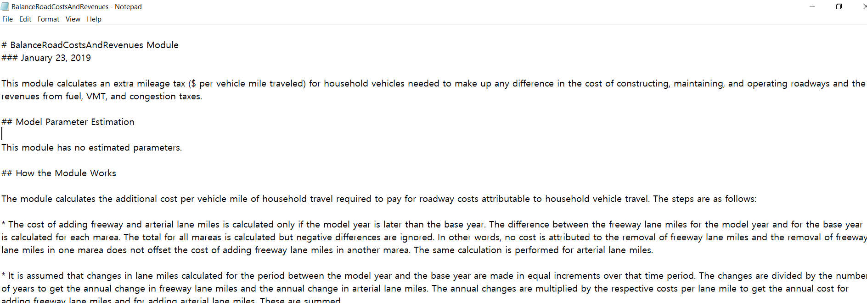

- Input Format Logic: According to the module documentation for BalanceRoadCostsAndRevenues, users are allowed to specify the year of currency directly within the field name. Specifically, when the TYPE is set to "currency", the field name must be followed by a period and the year the values are denominated in. This implies that users do not need to manually convert currency values to the model’s base year (e.g., 2005), as the system handles that internally.

NAME - The field (column) name in the input file. Note that if the 'TYPE' is 'currency' the field name must be followed by a period and the year that the currency is denominated in. For example if the NAME is 'HHIncomePC' (household per capita income) and the input values are in 2010 dollars, the field name in the file must be 'HHIncomePC.2010'. The framework uses the embedded date information to convert the currency into base year currency amounts. The user may also embed a magnitude indicator if inputs are in thousand, millions, etc. The VisionEval model system design and users guide should be consulted on how to do that.

- Conclusion: Input variable names can be updated to reflect the actual year of the cost values provided (e.g., RoadBaseModCost.2022). This approach allows the model to apply the necessary deflation logic internally and avoids unnecessary manual adjustments.

